DotNetDynDnsSvc Setup and Deployment

Contents

Web Server Requirements 1

Importing the Security Certificate 1

Site Installation 6

# Web Server Requirements

* OS: 2016+
* OS Roles:
  + Web Server (IIS)
* OS Features:
  + Under web server:
    - IIS Management Console
    - ASP.Net 4.6
* Web Server Role Services:
  + ASP.Net 4.6 (and dependencies)

Upgrade .net to 4.7.2. runtime.

# Importing the Security Certificate

Import the Security Certificate into the Local Machine Store on each web server that will be running this web site.

Right click the PFX archive and choose “Install PFX”. Make sure to check the “Mark Private Key as Exportable” during the certificate import wizard as this is needed for the web site to gain access to the private key for decryption purposes.

Import Certificate Wizard Step-by-Step:

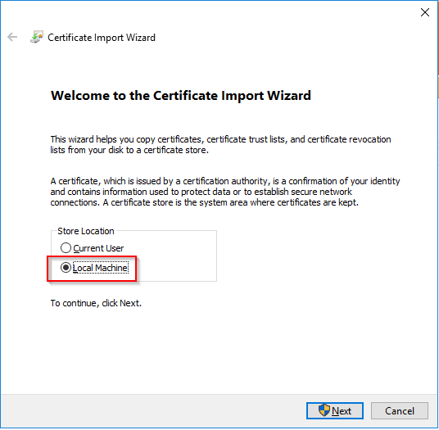

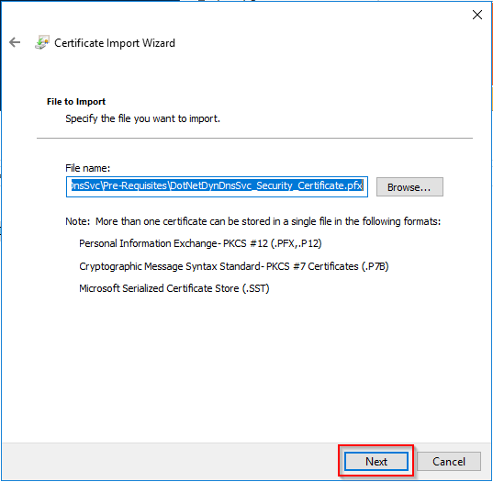

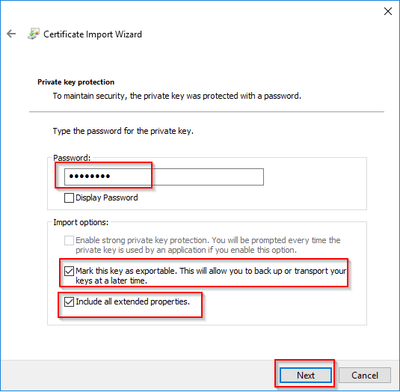

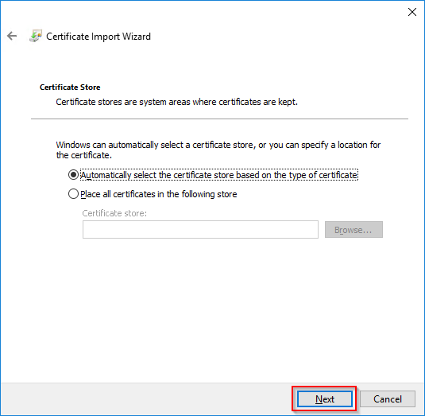

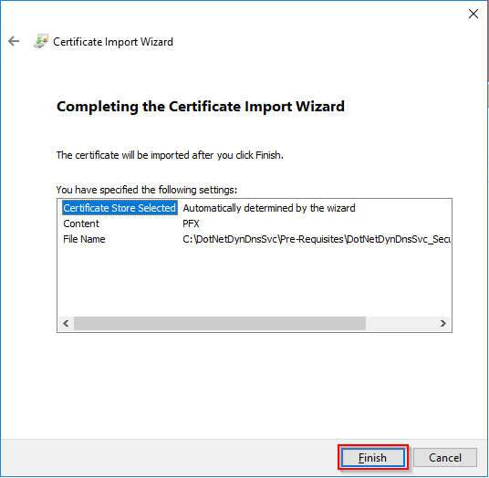

Open a new ‘mmc.exe’ window. Add the certificates snap-in (File -> Add Remove Snap-In, Certificates, click on “Add”), and configure it for the Local Machine:

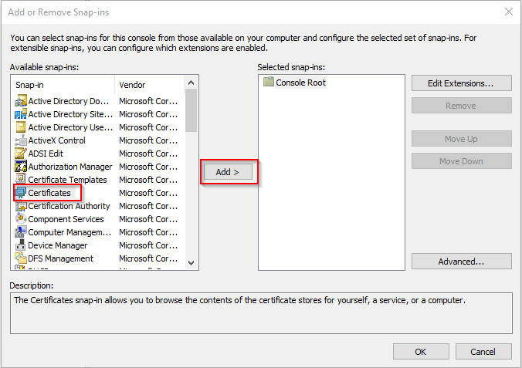

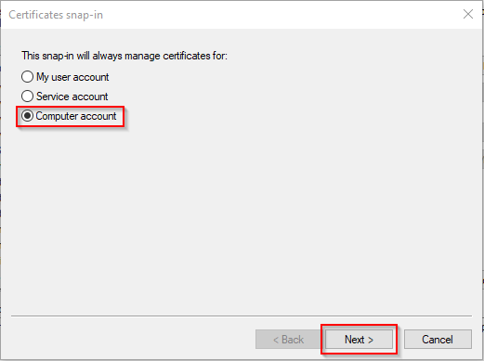

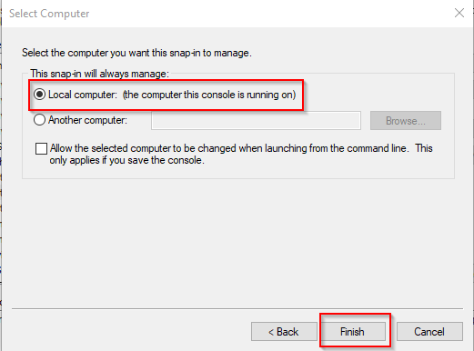

Navigate to Personal -> Certificates, and find the certificate that was just imported:

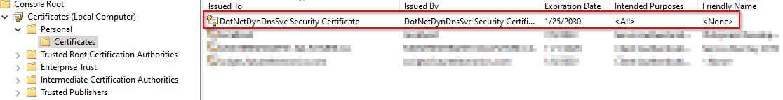

Right click it, All tasks -> Manage Private Keys. In the security window that pops-up, add the IIS_USERS group, and select “Read-Only”. This will allow IIS to have read access on this private key, which the application requires.

# Site Installation

Create a folder that will contain the web site and required folder structure. The folder can exist anywhere on the server. The folder structure required is:

* <some folder somewhere – called whatever you want>
  + Conf
    - Contains the web site yaml configuration file
    - Local IUSR account read-only
  + DB
    - Contains the SQLite Database
    - Local IUSR account read only
  + Logs
    - All custom application logs will be written here
    - Local IUSR account read/write
  + wwwroot
    - the folder containing the web site
    - Local IUSR account read only

The release zip files already have this folder structure setup, all you can simply extract the zip file in a parent folder somewhere, and then set the NTFS security permissions as defined above.

In IIS, create a new web site and name it accordingly (perhaps something like: dnsupdates.mydomain.com). The physical path should be the wwwroot directory that was created above. Set the host headers and port accordingly. Web site should have anonymous user authentication using the IUSR account. No other authentication methods should be selected (ASP.Net, Forms, Basic, all disabled), like so:

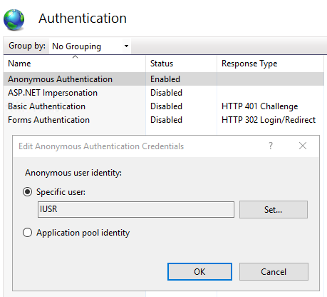

Ensure that the web site is running in a dedicated application pool in Basic Settings:

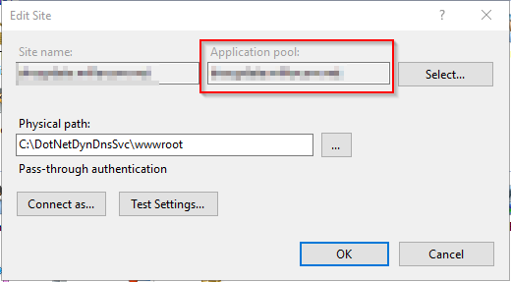

**NOTE**: This web site MUST use SSL or be behind a load-balancer that terminates SSL. Do not run this service using unencrypted HTTP over the internet.